Name: GADDE TEJA SAI
Roll No: AP25110070720
Subject: Data structure
Assignment: Lab Task-4
GitHub Link: https://github.com/tejasaigadde
- In a web crawler and search engine system, web pages are represented as nodes in a graph, and page-to-page hyperlinks are represented as edges. Since each web page typically links to only a few other pages, the adjacency matrix representing these links contains a large number of zero entries. To optimize memory usage, the page-to-page links are stored using a sparse matrix representation implemented with arrays (3-tuple form), Given the sparse matrix representation of page-to-page links, compute the transpose of the sparse matrix using arrays.
CODE:
#include <stdio.h>

int main() {
int sparse[20][3], transpose[20][3];
int n, i;

printf("Enter number of non-zero elements: ");
scanf("%d", &n);

printf("Enter row col value:\n");
for(i = 0; i < n; i++)
scanf("%d %d %d", &sparse[i][0], &sparse[i][1], &sparse[i][2]);

for(i = 0; i < n; i++) {
transpose[i][0] = sparse[i][1];
transpose[i][1] = sparse[i][0];
transpose[i][2] = sparse[i][2];
}

printf("\nTranspose matrix:\n");
for(i = 0; i < n; i++)
printf("%d %d %d\n", transpose[i][0], transpose[i][1], transpose[i][2]);
return 0;

}
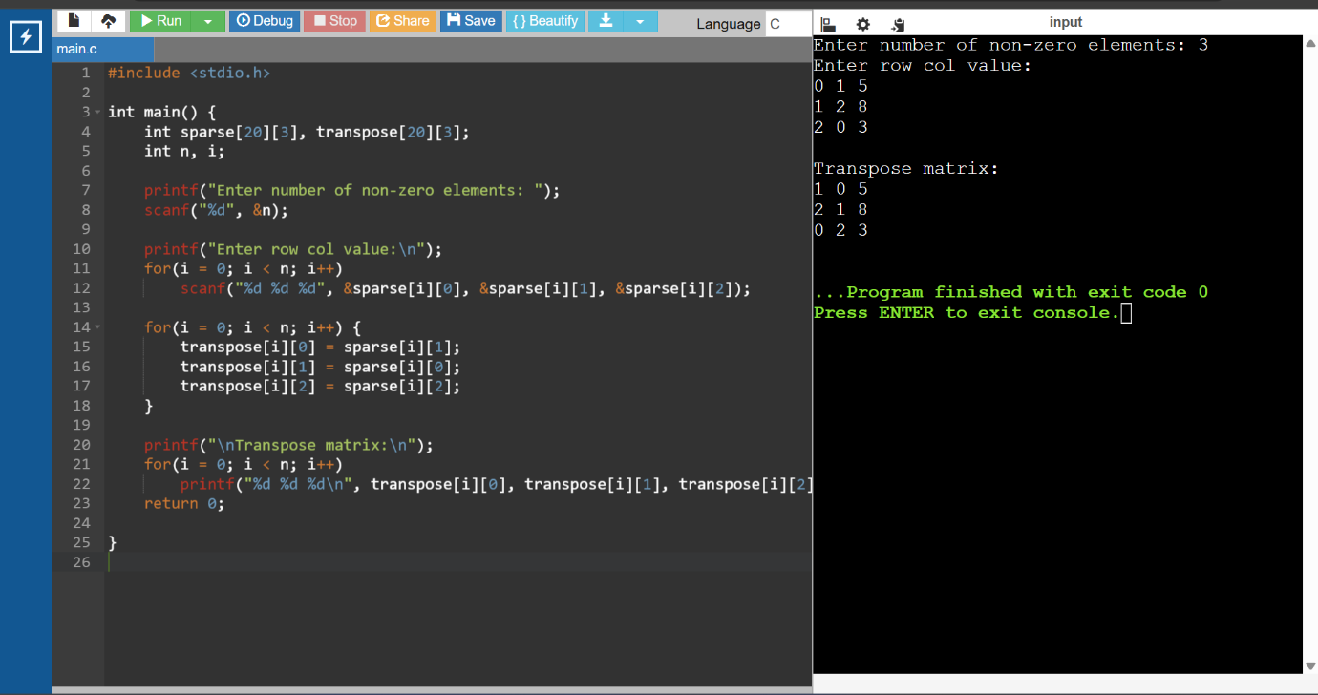
- In an loT-based environmental monitoring system, data collected from multiple sensors are stored in matrix form. Since most sensor readings are zero at any given time, the datasets are stored using sparse matrix representation implemented with arrays to reduce memory usage. Two sparse sensor datasets, collected from different regions, need to be merged to generate a consolidated dataset for further analvsis Write a C program to perform the addition of two sparse matrices using array-based sparse matrix representation.
CODE:
#include <stdio.h>
int main() {
int A[20][3], B[20][3], C[40][3];
int m, n, i, j, k = 0;
printf("Enter non-zero elements in matrix A: ");
scanf("%d", &m);
printf("Enter row col value:\n");
for(i=0;i<m;i++)
scanf("%d%d%d",&A[i][0],&A[i][1],&A[i][2]);
printf("Enter non-zero elements in matrix B: ");
scanf("%d", &n);
printf("Enter row col value:\n");
for(i=0;i<n;i++)
scanf("%d%d%d",&B[i][0],&B[i][1],&B[i][2]);
i=0; j=0;
while(i<m && j<n){
if(A[i][0]==B[j][0] && A[i][1]==B[j][1]){
C[k][0]=A[i][0];
C[k][1]=A[i][1];
C[k][2]=A[i][2]+B[j][2];
i++; j++; k++;
}
else if(A[i][0]<B[j][0] ||
(A[i][0]==B[j][0] && A[i][1]<B[j][1])){
C[k][0]=A[i][0];
C[k][1]=A[i][1];
C[k][2]=A[i][2];
i++; k++;
}
else{
C[k][0]=B[j][0];
C[k][1]=B[j][1];
C[k][2]=B[j][2];
j++; k++;
}
}
while(i<m){ C[k][0]=A[i][0]; C[k][1]=A[i][1]; C[k][2]=A[i][2]; i++; k++; }
while(j<n){ C[k][0]=B[j][0]; C[k][1]=B[j][1]; C[k][2]=B[j][2]; j++; k++; }
printf("\nResult matrix:\n");
for(i=0;i<k;i++)
printf("%d %d %d\n",C[i][0],C[i][1],C[i][2]);
return 0;
}
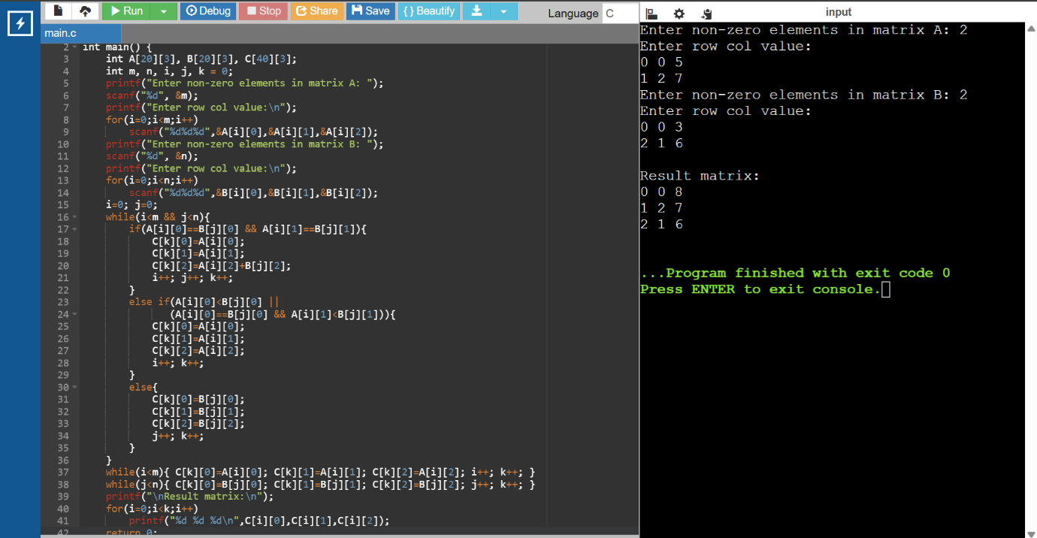

- In an electrical power grid management system, daily power consumption patterns are modeled using polynomial equations, where each term represents the contribution of different factors such as industrial load, residential usage, and peak-hour demand. These polynomial equations are stored using arrays to facilitate efficient computation. To analyze the combined power consumption from two different regions, the system needs to add two polynomial equations. (Implement in C language).

CODE:

#include <stdio.h>

int main() {
int a[10], b[10], sum[10], n, i;

printf("Enter highest degree: ");
scanf("%d",&n);

printf("Enter coefficients of first polynomial:\n");
for(i=0;i<=n;i++)
scanf("%d",&a[i]);

printf("Enter coefficients of second polynomial:\n");
for(i=0;i<=n;i++)
scanf("%d",&b[i]);

for(i=0;i<=n;i++)
sum[i]=a[i]+b[i];

printf("\nResult polynomial:\n");
for(i=n;i>=0;i--)
printf("%dx^%d ",sum[i],i);

return 0;
}

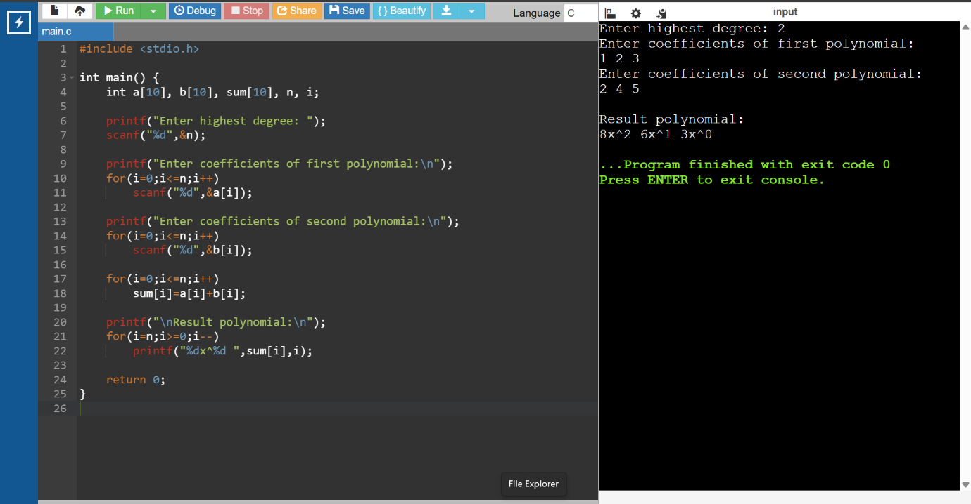

- 4. In a digital signal processing (DSP) system, digital fiters are commonly represented using polynomial equations, where the coefficients correspond to filter weights and the exponents represent delay elements. Suppose two digital filters are represented as polynomials stored using arrays. To analyze the combined effect of applying both filters in sequence, the system needs to compute the multiplication of the two polynomials.
Task: Write a C program to: Store two polynomials using arrays, Perform polynomial multiplication, Display the resulting polynomial in standard form.
CODE:
#include <stdio.h>

int main() {
int a[10], b[10], mul[20]={0};
int m,n,i,j;

printf("Enter degree of first polynomial: ");
scanf("%d",&m);
printf("Enter coefficients:\n");
for(i=0;i<=m;i++)
scanf("%d",&a[i]);

printf("Enter degree of second polynomial: ");
scanf("%d",&n);
printf("Enter coefficients:\n");
for(i=0;i<=n;i++)
scanf("%d",&b[i]);

for(i=0;i<=m;i++)
for(j=0;j<=n;j++)
mul[i+j]+=a[i]*b[j];

printf("\nResult polynomial:\n");
for(i=m+n;i>=0;i--)
printf("%dx^%d ",mul[i],i);

return 0;
}
